
Indian School Al Wadi Al Kabir
Assessment – 1
INFORMATICS PRACTICES (Code: 065)

CLASS: XII Max. Marks:70
Date: 20/09/2026 Time: 3 hours

General Instructions:
● The examination paper contains five sections, from Section A to Section E.
- Section A consists of 21 questions (1 to 21). Each question carries 1 Mark.
- Section B consists of 7 questions (22 to 28). Each question carries 2 Marks.
- Section C consists of 4 questions (29 to 31). Each question carries 3 Marks.
- Section D consists of 2 questions (32 to 35). Each question carries 4 Marks.
- Section E consists of 3 questions (36 to 37). Each question carries 5 Marks.
- All programming questions are to be answered using Python Language only.
● In case of MCQ, text of the correct answer should also be written.

 | SECTION A
1. | True or False: A DataFrame can have duplicate index labels. |  | 1
2. | Which of the following statements is replacing missing values of Series A and Series B by 100 .  - >>> A.add(B, fill_value = 100)  - >>>A.add(B, fill_value : 100)  - >>> A.add(B, fill-value = 100)  - >>> A.add(B, fill-value : 100) |  | 1
3. | Consider the following series named animal:  L Lion  B Bear  E Elephant  T Tiger  W Wolf  dtype: object  Write the output of the command: print(animal[::-3]).  - L Lion  T Tiger  - B Bear  E Elephant  - W Wolf  B Bear  - W Wolf  T Tiger |  | 1
4. | Which statement is true about the AVG () function?  - It includes NULL values in the calculation  - It ignores NULL values in the calculation  - It treats NULL values as zero  - It returns NULL if any value in the column is NULL |  | 1
5. | What will happen if we use ORDER BY to sort data of a column in ascending order that contains NULL values?  - NULL values will be sorted first  - NULL values will be sorted last  - NULL values will cause an error  - NULL values will be excluded from the result |  | 1
6. | df1.loc[ ] method is used to ______ # df1 is a DataFrame  - Add new row in a DataFrame ‘df1’  - To change the data values of a row to a particular value  - Both of the above  - None of the above |  | 1
7. | Krishna wants to display the unique departments from table emp. Which of the following is the correct statement for him?  - Select unique department from emp;  - Select distinct department from emp;  - Select department from emp;  - Select department(unique) from emp; |  | 1
8. | import pandas as pd  S1=pd.Series([1,2,3,4])  S2=pd.Series([7,8,9,10])  S2.index=['a','b','c','d']  print((S1+S2).count())  - 8  - 4  - 0  - 6 |  | 1
9. | Fill in the blank to get the output as 71.  import pandas as pd  s1=pd.Series([10,20,30,40,71,50])  print(s1[_________]) |  | 1
10. | Which SQL statement do we use to display the records present in the table ORDERS in the descending order of their bill amount?  - SELECT * FROM ORDERS GROUP BY BILL_AMOUNT ASC;  - SELECT * FROM ORDERS HAVING BILL_AMOUNT DESC;  - SELECT * FROM ORDERS ORDER BY BILL_AMOUNT;  - SELECT * FROM ORDERS ORDER BY BILL_AMOUNT DESC; |  | 1
11. | Which attribute returns the number of rows and columns in a DataFrame df?  - df.length  - df.size  - df.shape  - df.dimension |  | 1
12. | The correct statement to read from a CSV file in a dataframe is:  - <DF>.read_csv(<file>)  - <File>.read_csv( )(<DF>)  - <DF>=pandas.read(<file>)  - <DF> = pandas.read_csv(<files>) |  | 1
13. |  | Which command will display the datatype of a Series S?  - S.dtype  - S.datatype()  - S.datatypes  - S.dtypes() | 1
14. | Which type of plot in python matplotlib is used to count how many values fall into each interval?  - Line plot  - Bar graph  - Histogram  - Pie chart |  | 1
15. | A school database contains a table named STUDENT. The administrator no longer needs this table and wants to permanently remove the table along with all its records and structure. Which SQL command should be used?  - DELETE  - REMOVE  - CLEAR  - DROP |  | 1
16. | Which command is used to modify existing records?  - MODIFY  - CHANGE  - UPDATE  - ALTER |  | 1
17. | Consider the following code.  import pandas as pd  df = pd.DataFrame({ 'A': [10, 20, 30], 'B': [40, 50, 60]})  print(df.iloc[:, 0])  What will be displayed?  - First row  - First column  - Last column  - All rows |  | 1
18. | Which function is used to display the cardinality of a table in a database?  - sum(*)  - total(*)  - count(*)  - return(*) |  | 1
19. | Data in a DataFrame can be written to a text file on disk by using the pandas ____________ function.  - DataFrame.to_ csv()  - DataFrame.from_csv()  - DataFrame.to-csv()  - DataFrame.csv_from() |  | 1
20. | Assertion (A): Line charts are best used to display data that changes over time.  Reason (R): Line charts help in observing trends and patterns in time-series data.  - Both A and R are true and R is the correct explanation for A  - Both A and R are true and R is not the correct explanation for A  - A is True but R is False  - A is false but R is True |  | 1
21. | Assertion (A): Sorting is the operation to arrange data in a specific order ,sort_values ()  function used to perform the operation  Reasoning (R): Row wise sorting cannot be performed in python dataframe objects  - Both A and R are true and R is the correct explanation for A  - Both A and R are true and R is not the correct explanation for A  - A is True but R is False  - A is false but R is True |  | 1
 | SECTION B
22. | Differentiate between IN and BETWEEN operators with examples. |  | 2
23. | Consider the below given data frame df :  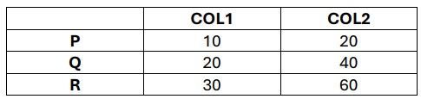  Write python code for the following:  - Add A new row ‘S’ with elements 40, 80  - Delete column ‘COL2’ from dataframe df. |  | 2
24. | Consider the following Series object, “company” and its profit in Crores  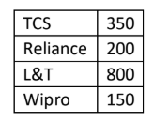  - Write the command which will display the name of the company having profit>250.  - Write the command to name the series as Profit. |  | 2
25. | Write a Python Program to create a Pandas Series, ‘Fruits’ as given below using a numpy array.  Apple 250  Orange 150  Grapes 230  Guava 180  Mango 240 |  | 2
26. | Given two series S1 and S2  S1 S2  A 39 A 10  B 41 B 10  C 42 D 10  D 44 F 10  Find the output for following python pandas statements?  - S1[ : 2]*100  - S1 * S2 |  | 2
27. | A school database contains a table named STUDENT that stores student details. The school decides to start recording the phone numbers of students. Later, it decides to remove this information from the database.  Write the SQL commands to:  - Add a new column Phone of suitable data type to the STUDENT table.  - Remove the Phone column from the STUDENT table. |  | 2
28. | Differentiate between char and varchar with suitable examples. |  | 2
 | SECTION C
29. | A library wants to maintain details of books, based on the following table structure. Write MySQL statements for the following:  - To create a database named ‘Library’.  - To create the table ‘Book’ using appropriate constraints.  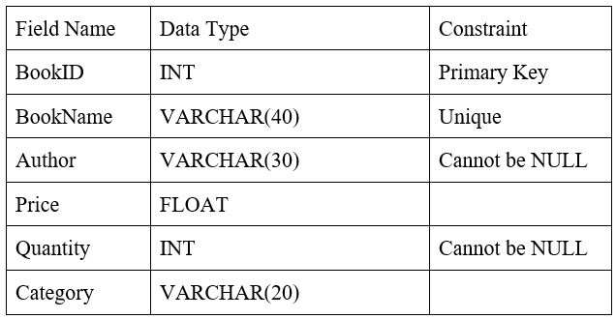 |  | 3
30. | A sports academy wants to maintain the performance details of its players. Using the given data, write Python statements to create a Pandas DataFrame named ‘Player’ using List of Dictionary. |  | 3
   | Player_Name | Sport | Score
  P101 | Arjun | Cricket | 85
  P102 | Riya | Tennis | 92
  P103 | Kabir | Football | 78
  P104 | Meera | Badminton | 88
  P105 | Rahul | Basketball | 81
31. | Consider the following dataframe df1 as shown below:  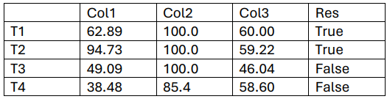  What will be the output produced by following statements?  - print(df1.loc [ :, ’Col3’ : ] )  - print(df1.iloc[2: , : 3] )  - print(df1.iloc [ 1:3 , 2:3 ]) |  | 3
32. | Write MySQL statement for the following:  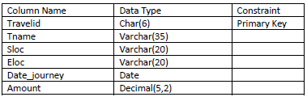  - Insert the following data in the TRAVELS Table  [A001, Raman, Delhi, Abu Dhabi,12-Jan-07,45.5]  - Write a command to remove the primary key constraint from the above given table.  - Write a command to change the datatype of amount where it can store up to 6 digits having 2 digits after decimal. |  | 3
 | SECTION D
33. | Consider the following Teacher table and write SQL output for the given query.  Note: Blank space means NULL value.  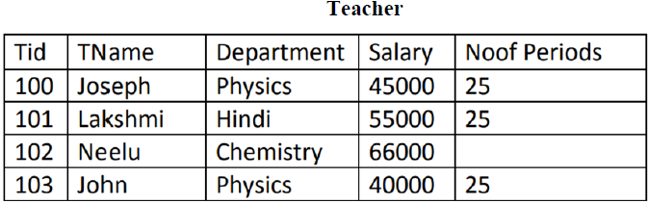  - Select * from Teacher order by Salary desc;  - Select avg (NoofPeriods), max(salary), min(salary ) from Teacher;  - Select Tname, Department from Teacher where salary between 45000 and 65000;  - Select count(*) , count(NoofPeriods) from Teacher; |  | 4
34 | - What is Data Visualization? How it can be achieved using python and give its any two benefits.  - Consider the below given DataFrame named Doctor.  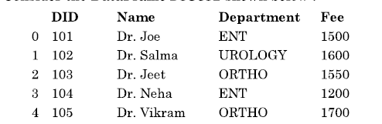  - Write a python command to change the column label to Doctor_name and Price for a given Name and fee column respectively.  - Write a python command to add new column having experience of each doctor with the following values: [3,12,10,11,4] |  | 2+2
 | SECTION E
35. | Write a python code to draw the following bar graph representing the average marks secured by each student in Term-2 Exam. Add the Title and Label for X-axis and Y-axis. Use the following data to draw the graph:  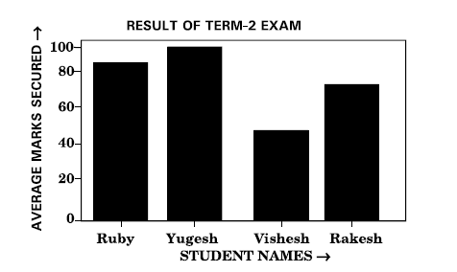  import _____ as plt #Statement-1  students = ['Ruby’, ‘Yugesh’, ‘Vishesh’, ‘Rakesh’]  marks = [84,92,45,72]  plt.bar( students, _____) #Statement-2  plt.xlabel(‘STUDENT NAMES —>’')  plt._____(‘AVERAGE MARKS SECURED —>’') #Statement-3  plt.title('_____') #Statement-4  plt.show()  plt.________________ #Statement-5  - Write the suitable code for the import statement in the blank space in the line marked as Statement-1.  - Refer to the graph shown above and fill in the blank in Statement-2 with suitable Python code.  - Fill in the blank in Statement-3 with the name of the function to set the label on the y-axis.  - Refer the graph shown above and fill the blank in Statement-4 with suitable Chart Title.  - Write the suitable code to save the image with the name ‘Marks’. |  | 5
36. | Consider the following Data Frame ProjectDF.  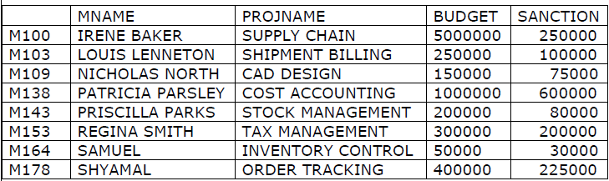  (A) Predict the output of the following python statements:  i. ProjectDF[‘PROJNAME’]  ii. ProjectDF.loc[‘M138’: ‘M164’]  iii.ProjectDF.shape  (B) Predict the output of the following python statement:  - ProjectDF.iloc[2:5,[0,2]]  OR (Option for part (B) only)  - Write a Python statement to compute and display the BudgetBalance  (BUDGET – SANCTION) for the above given DataFrame. |  | 5
37 | Consider the table CUSTOMER given below. Write commands in SQL for the following questions.  Note: Blank space means NULL value.  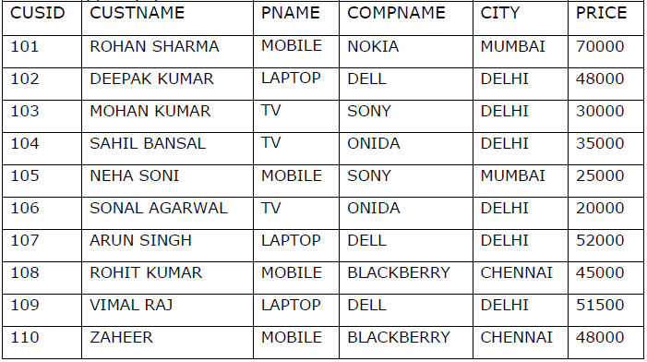 |  | 5
- Display the Customer ID, Customer Name, Product Name and Price details from the table in which Customer name ends with “AL” in its name.
- Display the details of the customers who are not from the city MUMBAI or CHENNAI.
- Display customer name, product name for those customers who have paid the amount.
- Change the details of customers who are using DELL products by increasing their price by 2000.
- To remove the details of customers where company name is Sony.
- Display the Customer name and product name of the customers from Delhi in the increasing order of price.
- Remove the details of the customers whose price does not come in the range 40000 and 50000.
- Display the name of the customers whose name doesn’t contain the letter ‘E’ in it.
- Display the number of customers whose product is TV.
- Remove entire details from the table Customer keeping the table intact.

